DRAFT - ICT Project Guidance

Definition – Default User Requirements

Version:

0.1

Author:

Sky Sigal, Solution Architect

## Description

This document lists default user requirements for information services, irrespective of the specific business case.

## Synopsis

This document lists functional requirements expected by non-business users – the users who will be supporting service users, as well as users who will be operating the system, monitoring, maintaining and evolving it over the service’s full lifespan.

## Contents

Description 1

Synopsis 1

Contents 2

Introduction 4

Tiers 4

Categories 4

Sub-Categories 5

Content 5

Questions and Response 6

Meanings 6

Default Functional Requirements 8

Project Specific Default Functional Requirements 9

Organisation (New Zealand Ministry of Education) Specific Functional Requirements 10

Sector (New Zealand Education) Specific Functional Requirements 10

Business Support Specialist Users 11

Sector (New Zealand Government Organisation) Specific Functional Requirements 12

Public Users 12

Business Support Specialist Users 13

National (New Zealand) Specific Functional Requirements 14

Public Non-Authenticated Users 14

Default ICT Functional Requirements 16

Public Non-Authenticated Users 16

Public Authenticated Users 20

Customer Support Users 23

Business Support Specialist Users 24

Business Service Provider Specialist Users 25

Business Product Development Users 26

System Operations Specialist Users 26

Monitoring Specialist Users 28

System Maintenance Specialists 29

Development Specialists 30

Service Daemon 31

Appendices 33

Appendix A - Document Information 33

Versions 33

Images 33

Tables 33

References 33

Review Distribution 33

Audience 33

Structure 33

Diagrams 34

Terms 34

## Introduction

Solutions and their components are described using Requirements. Risk to project delivery is increased when described with an insufficient number of requirements. On the other hand, Risk to projects may be increased when RFx respondents avoid responding due in part to the number of requirements given.

### Tiers

A solution to the above dilemma is an improved organisation of the requirements into Tiers to permit mature and experienced respondents to concentrate on the few specific requirements, and potentially skim over the requirements they would already familiar with (Default system requirements, and potentially the Government and/or Education Sector requirements built on top of them).

The tiers used in this document are:

* Project Specific
* Organisation Specific
* Sector Specific
* Default/Technology Specific

### Categories

Under each of the above Tiers, requirements are organised by User Role.

In this document, the Roles for whom requirements are developed include:

* **Public Users**: users who are not authenticated.
* **Authenticated Users**: users who have authenticate themselves.
* **General Customer Users**: first point of contact for general assistance, who may have to pass the request on to Business Support Users, or System Operations Specialists.
* **Business Support Users**: more specific assistance of business service providers and business service consumers,
* **Business Service Provider Users**: business users who provider the service and products to service consumers,
* **Business Resource Development Users**: developers of the resources that are part of the business service. These may be the same people as the Business Service Providers, or 3rd parties commissioned to just develop the resources,
* **System Operations Specialist Users**: users who configure all of system settings, etc.
* **System Monitoring Specialist Users**: users who develop monitoring of qualities of the system to alert Maintenance specialists.
* **System Maintenance Specialist Users**: users who maintain the underlying infrastructure and dependent components the system is developed from. They may need to view the system – or a real time report generated by the system -- to ascertain it and its dependency components are currently up, functioning and accessible.
* **Service Daemon User**: the system’s authenticated service agent that runs asynchronous audited tasks in the background. There is only one instance.
* **System Delivery Specialists**: the specialists who develop the automation pipelines that compile, test, package, deploy the solution’s components, who need very minimal access -- just enough to ascertain the deployment has been successful.

Note:  
If functionality is required by multiple roles, the functionality will be listed under each requirement.

### Sub-Categories

Under each of the above Category of users role, requirements may be further organised into sub categories as required.

In this document, sub-categories include:

* Diagnostics & Errors
* Configuration & Settings
* Discovery (both by Navigation and Search)
* Authentication and Authorisation
* Validation
* Notification
* Reporting

### Content

The requirements are given a unique ID, a short Title[1], a Statement, described further in with Details with accompany Notes to facilitate implementation.

* ID
* : a unique text and number identifier (e.g.: FR-DEF-01)
* **Title**
* : a unique title that is kept short with the intention that it can be used in diagrams,
* **Statement**
* : a stated objective that includes an obligations category (MAY|SHOULD|MUST [NOT]), is developed according to SMART design guidelines, and is suitable for contractual reasons[2],
* **Rational**
* : the reason for the obligation.
* **Details**
* : notes on aspects to consider regarding implementing the Statement.
* **Fit**
* : the measurable acceptance criteria.
* **Questions**
* : questions to guide the RFx respondents filling in the Response.
* **Response**
* : a column suitable for RFx respondents to describe how their proposed solution does or does not meet or exceeds the singular requirement.
* **Analysis**: notes as to analysis of the Response.

### Questions and Response

The Requirements are statements of the optimal desired objective that different Respondents will be able to implement to varying degrees.

If a respondent cannot meet the obligation’s statement, in the spirit of the Details given, the respondent may provide an Response that describes how their proposed solution can offer a comparable outcome, or make the requirement redundant.

### Meanings

A small number of specific phrases are used throughout the requirements, that are defined in the Appendices.

* **Proprietary Systems**
* Pre-developed Services that are licensed or
* **Custom Code**
* : any code that is developed to deliver this solution. This includes but is not limited to deployment pipeline instructions, scripted automation of route changes, infrastructure as code to develop environments via automation, custom modifications done to a proprietary system, static unit tests, dynamic acceptance tests developed using code, scripted automation of configuration steps, scripted automation setting changes, data storage schema definitions and their application, scripted automation of provisioning, scripted automation of data migration.
* **Documentation**

: includes documentation of development …

* **Deliverables**
* : these include…

# Default Functional Requirements

As outlined in the Introduction, Functional Requirements are defined below arranged into the following tier groups:

* **Project Specific**: varies per project.
* **Organisation (MOE) Specific**: this group’s requirements should be small or none at all, leveraging Sector specific requirements.
* **Sector Specific (Education)**: this tier has only a requirement around using the NSN.
* **Sector Specific (Government)**: a small number of requirements around archiving and transparency.
* **National (NZ) Specific**: NZ has a few requirements specific to meeting the Privacy Act 2020.
* **Baseline ICT:** requirements that mature systems should implement by default, regardless of whether they are defined by regulation or not.

## Project Specific Default Functional Requirements

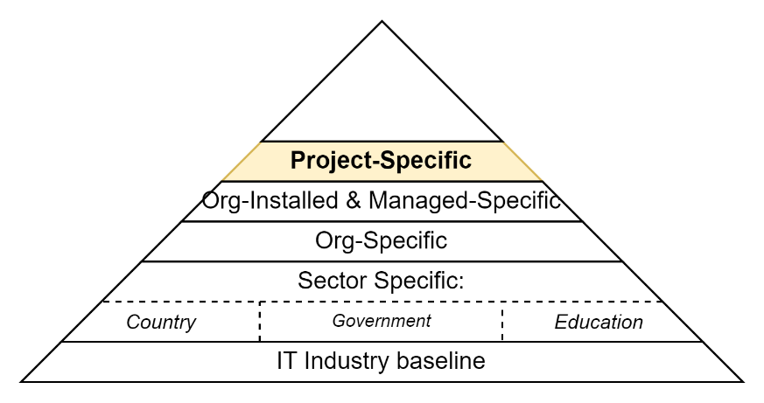

Figure : Project Specific Requirements

Important:  
While highly dependent on the maturity of the underlying organisations, this section should be small, reusing organisation defined processes where available, appropriate, current and correct.

## Organisation (New Zealand Ministry of Education) Specific Functional Requirements

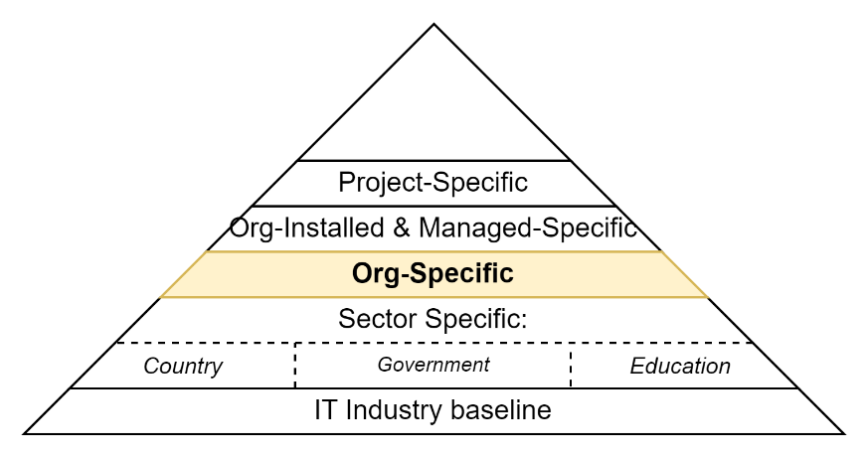

Figure : New Zealand Ministry of Education specific Requirements

The ministry has no specific requirements beyond meeting its all of government obligations.

## Sector (New Zealand Education) Specific Functional Requirements

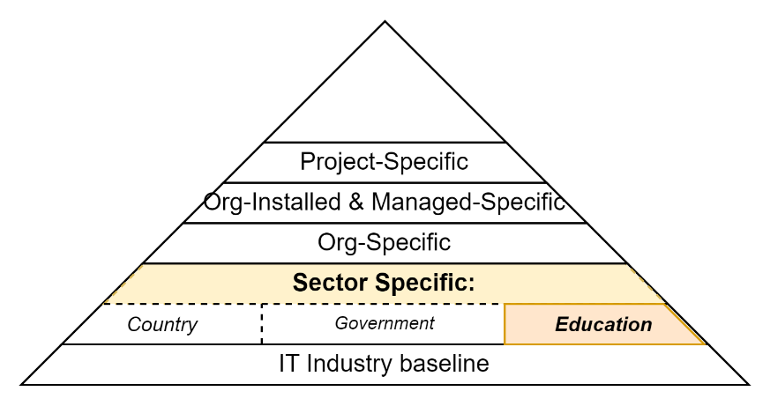

Figure : Sector (New Zealand Education) Default Functional Requirements

### Business Support Specialist Users

|  |  |  |  |  |  |  |  |  |  |  |
| --- | --- | --- | --- | --- | --- | --- | --- | --- | --- | --- |
|  | # | | ID | Statement | Rationale | Fit Criteria | Response | Comments | Details | Questions |
|  | þ **General** þ **Diagnostics** þ **Configuration** þ **Settings,** þ **Support** þ **Discovery/Navigation** þ **Discovery/Search** þ **Security** þ **Reporting** | | | | |  |  |  |  |  |
|  | **Navigation & Search** | | | | |  |  |  |  |  |
|  | FR- NZGOVT-00 |  | |  |  |  |  |  |  |  |
|  | **Discovery** | | | | |  |  |  |  |  |
|  | FR- NZMOE-01 | | NZMOE/ Authorised Users/ Discovery/ By NSN | Users SHOULD be able to search for users or user related resources managed by the system based on their National Student Number. | The National Student Number (NSN) is a learner’s unique compulsory education identifier within the compulsory education system.  It is learner’s most consistent attribute across multiple systems. |  |  |  | Note:  Note: NSNs MUST not be exported outside the system unless Approved to do so by Design Governance. | Is the proposed solution capable of managing an NSN attribute per learner?  Is the s proposed solution capable of reusing the system’s general search capabilities to find appropriate records based on it? |

## Sector (New Zealand Government Organisation) Specific Functional Requirements

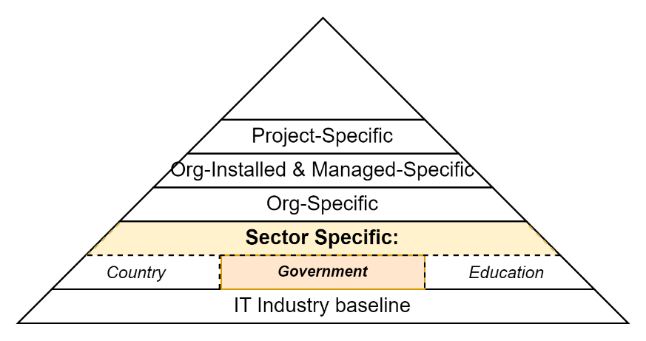

Figure : Sector (New Zealand Government Organisation) Default Functional Requirements

The following Functional Requirements are specific to New Zealand Government Organisations.

This set is small, built upon National and Default requirements defined later in the document.

### Public Users

|  |  |  |  |  |  |  |  |  |  |  |
| --- | --- | --- | --- | --- | --- | --- | --- | --- | --- | --- |
|  | # | | ID | Statement | Rationale | Fit Criteria | Response | Comments | Details | Questions |
|  | þ **General** þ **Diagnostics** þ **Configuration** þ **Settings,** þ **Support** þ **Discovery/Navigation** þ **Discovery/Search** þ **Security** þ **Reporting** | | | | |  |  |  |  |  |
|  | **Discovery – Statements** | | | | |  |  |  |  |  |
|  | FR- NZGOVT-00 | FR/ NZGOVT/ Public Users/ Discovery/ Disclosures | | Users of the system MUST be able to navigate to the latest various of the disclosure statements (Tracking, Data, Privacy, T&C,etc.) | Users must be able to |  |  |  |  |  |

### Business Support Specialist Users

|  |  |  |  |  |  |  |  |  |  |  |
| --- | --- | --- | --- | --- | --- | --- | --- | --- | --- | --- |
|  | # | | ID | Statement | Rationale | Fit Criteria | Response | Comments | Details | Questions |
|  | þ **General** þ **Diagnostics** þ **Configuration** þ **Settings,** þ **Support** þ **Discovery/Navigation** þ **Discovery/Search** þ **Security** þ **Reporting** | | | | |  |  |  |  |  |
|  | **Navigation & Search** | | | | |  |  |  |  |  |
|  | FR- NZGOVT-00 |  | |  |  |  |  |  |  |  |
|  | **Reporting** | | | | |  |  |  |  |  |
|  | FR- NZGOVT-00 | | FR/ NZGovt/ BizSupt/ OIA/ Status | The solution MUST provide the functionality necessary for a role to summarise the status of the services errors, and user base | Tax payers have the right to inquire as to quality of government services on which their taxes were spent. |  |  |  | OIAs may request insight into the qualities of the system, including its performance and reliability, and market uptake. |  |

## National (New Zealand) Specific Functional Requirements

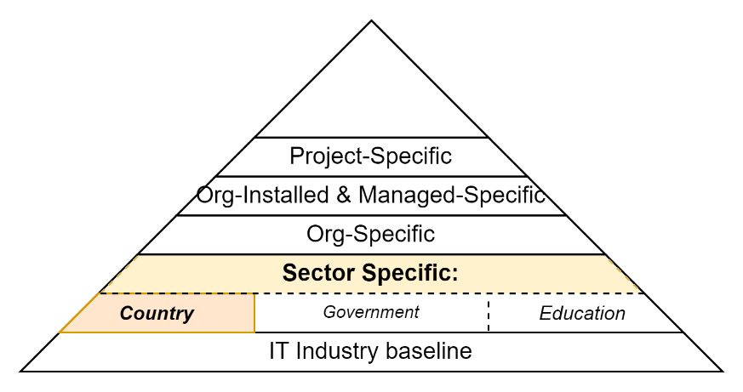

Figure 5: Default National functional requirements

For the most part this group of requirements addresses requirements of the Privacy Act 2020.

### Public Non-Authenticated Users

|  |  |  |  |  |  |  |  |  |  |  |
| --- | --- | --- | --- | --- | --- | --- | --- | --- | --- | --- |
|  | # | | ID | Statement | Rationale | Fit Criteria | Response | Comments | Details | Questions |
|  | þ **General** þ **Diagnostics** þ **Configuration** þ **Settings** þ **Support** þ **Discovery/Navigation** þ **Discovery/Search** þ **Security** þ **Reporting** | | | | |  |  |  |  |  |
| **General** | | | | | |  |  |  |  |  |
|  |  |  | | Users MUST be able to review and submit changes to their own Personal Identifying Information. | Persons know themselves best. |  |  |  |  | Does the proposed solution present a person’s personal information back to them?  Does the proposed solution permit the changes to be done by the end user, or do they have to propose changes for review and acceptance by a monitor? |
|  |  |  | | Users MUST be able to request that their personal information be removed from the system. |  |  |  |  |  |  |

## Default ICT Functional Requirements

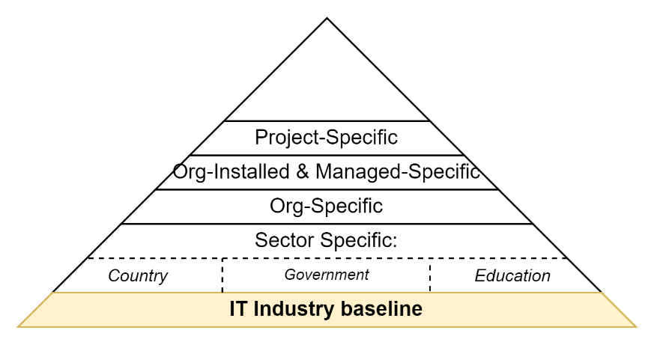

Figure : Default IT sector baseline functional requirements

### Public Non-Authenticated Users

|  |  |  |  |  |  |  |  |  |  |  |
| --- | --- | --- | --- | --- | --- | --- | --- | --- | --- | --- |
|  | # | | ID | Statement | Rationale | Fit Criteria | Response | Comments | Details | Questions |
|  | þ **General** þ **Diagnostics** þ **Configuration** þ **Settings** þ **Support** þ **Discovery/Navigation** þ **Discovery/Search** þ **Security** þ **Reporting** | | | | |  |  |  |  |  |
| **General** | | | | | |  |  |  |  |  |
|  |  |  | |  |  |  |  |  |  |  |
|  | **Settings - User Settings** | | | | |  |  |  |  |  |
|  | FR- PUB-00 | | FR/ Default/ Non-AuthN/ Configuration/ Accessible Pages | Public Non-Authenticated Users MUST access one or more system interfaces | Users should be able to see the service, and not be greeted with an unauthenticated error message. |  |  | A public home page provides a place for end users to discover the site, and from there discover and navigate to self-help and assisted support sites, etc. |  | Does the system offer a login page?  Does the system offer a public home page(s) accessible to non-authenticated users? |
|  |  | | FR/ Default/ Non-AuthN/ Language | Public Non-Authenticated MUST be able to specify their culture and region (e.g.: en-NZ, mi-NZ, etc.) before they sign in. |  |  |  |  | The cookie or URL variable used to roundtrip this preference must be updated from user settings once signed in. | Does the system provide the ability to provide interfaces in two or more cultures?  Does the system provide the functionality to change the default preference?  Does the system provide this functionality even before they are authenticated? |
|  |  | |  |  |  |  |  |  |  |  |
|  | **Discovery / Navigation** | | | | |  |  |  |  |  |
|  |  | | FR/ Default/ Non-AuthN/ Login | Public Non-Authenticated Users MUST be able to login in to the system. | Users should be able to self help themselves. |  |  | The functionality will link to an external Identity Provider. |  | Does the system currently link to cloud provider IdPs (Microsoft, Google, etc.)? Is the system modifiable to integrate more/alternate Identity Providers? |
|  |  | |  | Public Non-Authenticated Users MUST be able to access and use limited Navigation features. | Navigation provides a means for users to acquaint themselves with their digital environment, diminishing the need for assisted support. |  |  |  |  | Does the solution provide a Navigation capability?  Is it available to non-authenticated users?  If so, does the solution apply permission controls to restrict access to and/or remove specific items from being included in the search result? |
|  |  | | FR/ Default/ Non-AuthN/ Contact | Public Non-Authenticated Users MAY be able to launch functionality to Contact Us email (and optionally phone call). | Public users must have the means of asking for support without requiring users to sign up or into the service. Making it seamless where possible is just better design. |  |  |  | Consider using mailto://  Consider using the tel protocol as per RFC 2806 and  RFC 3966. <a href=”tel:012.../> | Is the site optimised to use mobile phone capabilities to contact assisted support? |
|  | **Discovery / Search** | | | | |  |  |  |  |  |
|  |  | |  | Public Non-Authenticated Users MUST be able to use Search features. | Search provides a means for users to find resources they are permitted to access, diminishing the need for assisted support. |  |  |  |  | Does the solution provide a Search capability?  Does it provide it to non-authenticated users?  If so, does the solution apply permission controls to restrict access to and/or remove specific items from being included in the search result? |

### Public Authenticated Users

|  |  |  |  |  |  |  |  |  |  |
| --- | --- | --- | --- | --- | --- | --- | --- | --- | --- |
|  | # | ID | Statement | Rationale | Fit Criteria | Response | Comments | Details | Questions |
|  | þ **General** þ **Diagnostics** þ **Configuration** þ **Settings** þ **Support** þ **Discovery/Navigation** þ **Discovery/Search** þ **Security** þ **Reporting** | | | |  |  |  |  |  |
|  | **General** | | | |  |  |  |  |  |
|  | FR-AUTHN- 00 |  | Authenticated Users MUST be able to perform the same functions as Public Non-Authenticated Users. | Users should not lose functionality by signing in. |  |  |  |  | Once signed in, do the data stored user preferences for GUI language/region setting take over and update from cookie used & set by non-authenticated users? |
|  | **Settings - System User Profile** | | | |  |  |  |  |  |
|  | FR-AUTHN- 00 |  | Authenticated Users MUST be able to configure personal system profile of settings. | Users should be able to configure their digital workspace to be as effective as practical. |  |  |  |  |  |
|  | FR-AUTHN- 00 |  | Authenticated Users MUST be able to configure the culture and region their GUI is displayed in. |  |  |  |  | This setting should replace the language cookie set when they not authenticated, so that the language setting remains correct when they sign out. | Does the system currently permit changing the interface language? |
|  | FR-AUTHN-00 |  | Authenticated Users MUST be able to configure their system profile’s personal Display Name | Users should be able to not share Personal Identifying Information (PII) if they don’t desire to do so. |  |  |  |  |  |
|  | **Settings –System User Security Profile** | | | |  |  |  |  |  |
|  | FR-AUTHN- 00 |  | Authenticated Users MUST be able to review their Security Profile. | A person should have the means to self-diagnose -- or provide context information to a business and operations support specialist -- the reason for being denied operations. |  |  |  | A Security Profile is the logical collection of a Person’s Role within Groups and/or on Resources, and therefore underlying Permissions that have been granted. |  |
|  |  |  | A User SHOULD be capable of making a request to be invited to a Role within a Group. | Users must be added to a group.  Delegation of the activity from manual Role Assignment to to automated Role Invitation Approval improves data quality and reduces the workload of users accountable for a group. |  |  |  | A mature process is based not on Assignment, but instead on a workflow of Application, Approving an Invitation issuing, Invitation Acceptance. |  |
|  | **Discovery - Search** | | | |  |  |  |  |  |
|  | FR-AUTHN- 00 |  | Authenticated Users MUST be able to Search for system Resources. | Users should learn a single area of functionality to later find most things in the system as intuitively as possible. |  |  |  | Best practice is to enable the user to select  - what they are searching for - filtered by a search term - the order in which results are returned  It is also best practice to return data in a system configurable lines per page. |  |
|  | **Notifications** | | | |  |  |  |  |  |
|  | FR-AUTHN- 00 |  | Authenticated Users MUST be able to read notifications intended for them. | Notifications may be for all users, but they should be able to read, and mark them as read and later search for and reopen them if necessary. |  |  |  | Best practice is to enable the user to select  - what they are searching for - filtered by a search term - the order in which results are returned  It is also best practice to return data in a system configurable lines per page. |  |

### Customer Support Users

Customer support specialists are the first point of contact for assistance.If they cannot handle the request, they pass the request to the Business Support specialist users, or directly Operations Specialists.

|  |  |  |  |  |  |  |  |  |  |
| --- | --- | --- | --- | --- | --- | --- | --- | --- | --- |
|  | # | ID | Statement | Rationale | Fit Criteria | Response | Comments | Details | Questions |
|  | þ **General** þ **Diagnostics** þ **Configuration** þ **Settings** þ **Support** þ **Discovery/Navigation** þ **Discovery/Search** þ **Security** þ **Reporting** | | | |  |  |  |  |  |
|  | **Security** | | | |  |  |  |  |  |
|  | FR-CUSTSUP- 00 |  | Customer support personnel MUST be able to instruct users how to self-reset their credentials. | Year after year, the result of surveys of the number one request to customer support in any organisation is always about users asking for assistance to get around forgotten passwords. |  |  |  | The functionality must not be part of the system itself, but of the IdPs it integrates with and depends on. |  |

### Business Support Specialist Users

Whereas general Customer Support specialists have little to no business specific knowledge, and only rudimentary system specific knowledge, Business support specialists have both specific business use case knowledge and knowledge of how to operate the system.

For example, they can provide tenant and user onboarding and setup assistance to external users as well as internal users (see Business Service Provider Specialist Users).

|  |  |  |  |  |  |  |  |  |  |
| --- | --- | --- | --- | --- | --- | --- | --- | --- | --- |
|  | # | ID | Statement | Rationale | Fit Criteria | Response | Comments | Details | Questions |
|  | þ **General** þ **Diagnostics** þ **Configuration** þ **Settings** þ **Support** þ **Discovery/Navigation** þ **Discovery/Search** þ **Security** þ **Reporting** | | | |  |  |  |  |  |
|  | **General** | | | |  |  |  |  |  |
|  | FR-BIZSUP- 00 |  | Business Support Users MUST be able to meet obligations by logically archiving data so that it is no longer retrievable or accessible by system users. | Regulations obligate system owners to remove information from user access under certain circumstances (usually a delay). |  |  |  |  |  |

### Business Service Provider Specialist Users

Business Service Providers are business users who develop and provide value for service consumers.   
They may develop information themselves or contract the development of information from 3rd parties (see *Business Information Specialists Users*, described next).

|  |  |  |  |  |  |  |  |  |  |  |
| --- | --- | --- | --- | --- | --- | --- | --- | --- | --- | --- |
|  | # | ID | | Statement | Rationale | Fit Criteria | Response | Comments | Details | Questions |
|  | þ **General** þ **Diagnostics** þ **Configuration** þ **Settings** þ **Support** þ **Discovery/Navigation** þ **Discovery/Search** þ **Security** þ **Reporting** | | | | |  |  |  |  |  |
|  | **General** | | | | |  |  |  |  |  |
|  |  | |  | Business Service Providers SHOULD be able to assist users to create new service consumer account groups. | Business service providers should have the ability to assist users to sign up their organisation -- for later invitation of users within their organisation. |  |  |  | Previously, Organisations were signed up Tenancies.   Since, the use of independent Tenancies has proven over time to be a low value pattern as it omits correct representation of users contributing to multiple organisations and resources being shared across them. |  |

### Business Resource Development Users

Whereas business service providers provide a *service*, these users develop the *product* – the resources -- hosted within the service.

|  |  |  |  |  |  |  |  |  |  |  |
| --- | --- | --- | --- | --- | --- | --- | --- | --- | --- | --- |
|  | # | ID | | Statement | Rationale | Fit Criteria | Response | Comments | Details | Questions |
|  | þ **General** þ **Diagnostics** þ **Configuration** þ **Settings** þ **Support** þ **Discovery/Navigation** þ **Discovery/Search** þ **Security** þ **Reporting** | | | | |  |  |  |  |  |
|  | **General** | | | | |  |  |  |  |  |
|  |  | |  | Resources MUST be able to be created remotely by external services. | Resources may be developed in 3rd party services, preferring an automated integration approach over a GUI Cut/Paste integration process. |  |  |  |  |  |
|  |  | |  | Users MUST be able to Draft new Resources within the system. | Users must develop new Resources. |  |  |  |  |  |
|  |  | |  | Users MUST be able to Draft Replacement Resources. |  |  |  |  |  |  |
|  |  | |  | Users MUST be able to Review Draft Resources for Approval. |  |  |  |  |  |  |
|  |  | |  | Users MUST be able to Approve Draft REsourcews for release/publishing. |  |  |  |  |  |  |
|  |  | |  | Users MUST be able to release/publish Approved resources. |  |  |  |  |  |  |
|  |  | |  | Users MUST be able replace an existing Resources with a new Approved Resource. | The old version shuodl |  |  |  |  |  |

### System Operations Specialist Users

System Operations specialists configure the system for use by Business Service Providers and Consumer Users.  
Best practice

|  |  |  |  |  |  |  |  |  |  |
| --- | --- | --- | --- | --- | --- | --- | --- | --- | --- |
|  | # | ID | Statement | Rationale | Fit Criteria | Response | Comments | Details | Questions |
|  | þ **General** þ **Diagnostics** þ **Configuration** þ **Settings** þ **Support** þ **Discovery/Navigation** þ **Discovery/Search** þ **Security** þ **Reporting** | | | |  |  |  |  |  |
|  | **System Settings** | | | |  |  |  |  |  |
|  |  |  | System Operations specialist users MUST be able to access a System Configuration Profile to configure all of System settings. | They must be able to update Logo, Title, Subtitle, default appearance settings, default settings, links to and or text of disclaimers, etc. |  |  |  | Note that all these system settings should also be configurable by API so that they can be configured by an step of a deployment pipeline.   Examples of settings include: - Sponsor information  - Logo  - Title - Subtitle/Description - default background - default appearance - default language/culture - default links to/and or text of disclaimers (tracking, data use, privacy) and terms and conditions. | Does the system have configurable system settings, controlled by Permission/Role? |
|  | FR-OPS- 00 |  | System Operations Users MUST be able to view current system status including service component state. | It is efficient for Operation specialists to rule out that the system is functioning incorrectly before expending the effort to delving into discovering further causes. |  |  |  | The summary should be able to communicate that connection to components are working as expected, error count, etc. |  |

### Monitoring Specialist Users

|  |  |  |  |  |  |  |  |  |  |
| --- | --- | --- | --- | --- | --- | --- | --- | --- | --- |
|  | # | ID | Statement | Rationale | Fit Criteria | Response | Comments | Details | Questions |
|  | þ **General** þ **Diagnostics** þ **Configuration** þ **Settings** þ **Support** þ **Discovery/Navigation** þ **Discovery/Search** þ **Security** þ **Reporting** | | | |  |  |  |  |  |
|  | **Diagnostics** | | | |  |  |  |  |  |
|  | FR-MON- 00 |  | System monitoring specialists MAY be able to define Alerts in the system. |  |  |  |  | The solution should not be in the system itself, but in an external monitoring service. But it does mean the system must develop and write to performance counters, etc. |  |

### System Maintenance Specialists

Although a generalisation, System Maintenance specialists only use the deployed to ensure it’s still working.   
Sometimes the system provides UX to investigate diagnostics and errors, but in most cases they instead view diagnostics and error reports in an external service that is used to monitor and diagnose the system and its infrastructure (which a system would not easily or safely be able to report on).

|  |  |  |  |  |  |  |  |  |  |
| --- | --- | --- | --- | --- | --- | --- | --- | --- | --- |
|  | # | ID | Statement | Rationale | Fit Criteria | Response | Comments | Details | Questions |
|  | þ **General** þ **Diagnostics** þ **Configuration** þ **Settings** þ **Support** þ **Discovery/Navigation** þ **Discovery/Search** þ **Security** þ **Reporting** | | | |  |  |  |  |  |
|  | **Diagnostics** | | | |  |  |  |  |  |
|  | FR-MAIN- 00 |  | Maintenance specialists MUST be able to query, filter, order, and page diagnostics trace messages. | Diagnostic log messages are the basis of tracking down abnormal behaviour that has caused an Exception Report. |  |  |  | Diagnostics log messages are temporal, and only kept for a configurable number of days (typically 31 days).  Viewing the records is not typically functionality provided by a service, so that it can be viewed even when the system is not working, but it is often a useful feature if it is.  They absolutely must not contain Personal Information or security credentials. | Does the system, roadmap or design currently include diagnostic tracing?  Is the duration which diagnostic trace records are kept configurable?  Where are they kept? (Noting that best practice cloud design patterns avoid the use of local file systems). |
|  | FR-MAIN-00 |  | Maintenance specialists MUST be enabled to query  (Filter, Count, OrderBy, Page) permanent Error Reports. | A report log is the basis of both investigating issues as the basis of creating and/or prioritising work items, as well as reporting on (hopefully) a decreasing number of errors as they are addressed. |  |  |  | Error reports are permanently logged, preferably in a non-tamperable manner, to data storage. |  |

### Development Specialists

|  |  |  |  |  |  |  |  |  |  |
| --- | --- | --- | --- | --- | --- | --- | --- | --- | --- |
|  | # | ID | Statement | Rationale | Fit Criteria | Response | Comments | Details | Questions |
|  | þ **General** þ **Diagnostics** þ **Configuration** þ **Settings** þ **Support** þ **Discovery/Navigation** þ **Discovery/Search** þ **Security** þ **Reporting** | | | |  |  |  |  |  |
|  | **General** | | | |  |  |  |  |  |
|  | FR-DEV- 00 |  |  |  |  |  |  |  |  |

### Service Daemon

The service daemon is the system’s underlying service account, which performs automation as an authenticated service account.

|  |  |  |  |  |  |  |  |  |  |
| --- | --- | --- | --- | --- | --- | --- | --- | --- | --- |
|  | # | ID | Statement | Rationale | Fit Criteria | Response | Comments | Details | Questions |
|  | þ **General** þ **Diagnostics** þ **Configuration** þ **Settings** þ **Support** þ **Discovery/Navigation** þ **Discovery/Search** þ **Security** þ **Reporting** | | | |  |  |  |  |  |
|  | **General** | | | |  |  |  |  |  |
|  | FR-DEV- 00 | FR/ Default/ Daemon/ Archive | The solution MUST be able to periodically scan for and Archive published resources that are older than a configurable duration. | Removing material that is no longer valuable ensures that the service’s remaining information remains relevant and current. |  |  |  |  | Does the service have an archiving feature?  Is the archiving process logical, or physical in that it moves it to another data store?  Can the archived data still be accessed by permitted users? |
|  | **Security** | | | |  |  |  |  |  |
|  | FR-DEV- 00 | FR/ Default/ Daemon/ Malware Scanning | The solution MUST be capable of scanning  stored media regularly at a configurable cadence using a regularly updated and current malware detection capabilities. | Users must be able to trust the service to not being a source of infection when they use it. |  |  |  |  | Does the solution scan uploaded media?  Does the scanning solution regularly update itself?  Does the solution scan stored media regularly?  Does the solution ensure that malware infected media is not available for download by any user (by quarantining, other)? |

Appendices

Appendix A - Document Information

Versions

* 1. Initial Draft
  2. Minor Updates

### Versions

0.1 Initial Draft

### Images

### Tables

### References

**There are no sources in the current document.**

### Review Distribution

The document was distributed for review as below:

|  |  |
| --- | --- |
| Identity | Notes |
| Sandy Britain, Enterprise Architect |  |
| Amy Orr, Data Domain Architect |  |
| Rodney Snell, Business & Technical Lead |  |
| Russell Campbell, Project Manager |  |

### Audience

The document is technical in nature, but parts are expected to be read and/or validated by a non-technical audience.

### Structure

Where possible, the document structure is guided by either ISO-* standards or best practice.

### Diagrams

Diagrams are developed for a wide audience. Unless specifically for a technical audience, where the use of industry standard diagram types (ArchiMate, UML, C4), is appropriate, diagrams are developed as simple “box & line” monochrome diagrams.

### Terms

Refer to the project’s Glossary.

##### GUI

: Graphical User Interface. As opposed to a Text or Console based User Interface (TUI) or Application Programming Interface (API).

##### IT

: acronym for Information, using Technology to automate and facilitate its management.

##### ICT

: acronym for Information & Communication Technology, the domain of defining Information elements and using technology to automate their communication between entities. IT is a subset of ICT.

##### IdP

: acronym for *Identity Provider*, a service that is specialised in validating submitted credentials, in return for a token that when a user presents it to a dependent service, is trusted it as being sufficient proof that the person is whom they say they are. The benefit of using an IdP is that the Person only needs share their credentials with a trusted IdP, over confidential channels, and not have to share their credentials with the dependent service.

##### SMART

: acronym used as guidance for developing valuable requirements: “*Singular, Measurable, Achievable, Reasonable, Time-based*”.

1. suitable for diagrams use if so desired
2. Do not confuse requirements, which are agreement/contractual statements, with work items (eg: user stories).